**This meeting is free for link delegates**

**includes morning coffee/lunch/tea**

**Visitors can join this meeting for £5 to cover all refreshments**

**ALTERNATIVELY, Visitors can join the meeting independently online - book through the link on My WI**

**NFWI ANNUAL MEETING 2025**

**TUESDAY 4TH JUNE**

**AT ALMA HOUSE, HG4 1NG**

**10.00 AM TO 4.00 PM**

**Delegates will require a Wi-Fi enabled device i.e. a smartphone, iPad or laptop to vote on constitutional items during the meeting.**

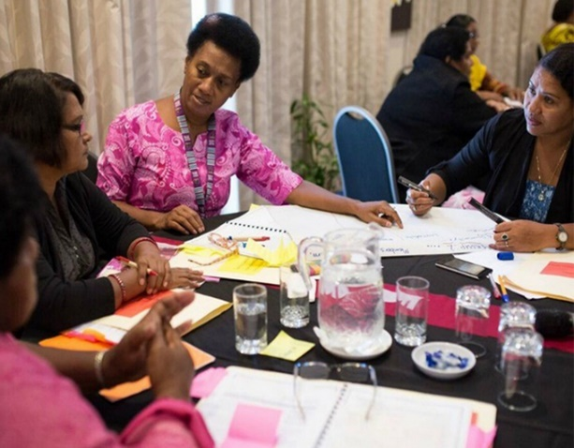

[This Photo](https://asiapacificreport.nz/2016/03/08/meet-the-incredible-women-protecting-their-communities-in-disaster-zones/) by Unknown Author is licensed under [CC BY-SA-NC](https://creativecommons.org/licenses/by-nc-sa/3.0/)

**Please note there is no parking at alma house**

***Closing Date: 31st January 2025***

**Confirmation will be issued by email after the closing date**

If the closing date has passed, please contact the Office for availability – 01765 606339

From: WI

|  |  |  |
| --- | --- | --- |
| **Name and telephone number of member attending** | **Email Address .** | **Please tick**  **Delegate - Visitor** |
|  |  |  |
|  |  |  |
|  |  |  |
|  |  |  |
|  |  |  |
|  |  |  |

**Payment Options**

**CHEQUE** payable for the full **AMOUNT** to NYWFWI and send to North Yorkshire West Federation of WIs, Alma House, Low St Agnesgate, Ripon, HG4 1NG. Please list the event on the reverse of the cheque.

**ONLINE-BACS** **Acc Name:** NYW Fed of Womens Institute No 1 A/C Charity No 1204475 **Sort code:** 05-07-17 **Account Number** 35739439 with Reference Name/WI and sending a confirmatory email with completed form to [NYWFWI24@gmail.com](mailto:NYWFWI24@gmail.com). Please quote code 25F01AM

|  |  |  |
| --- | --- | --- |
| Contact Name: Email: | | |
| Telephone Signed | | |
| **BOOKINGS are non-refundable.** | If the event is Cancelled cheques will be destroyed - please tick if you require your cheque returned. |  |

Confirmation will be emailed out to the contact’s name. Please note photographs taken at the event may be used on social media.

**DISCLAIMER**: Participants take part in **ALL** Federation events and activities at their own risk.