NORTHAMPTONSHIRE COUNTY FEDERATION

OF WIs

PAULINE DUFF TROPHY

2025

***THE LADY DENMAN RESTAURANT SHORTBREAD***

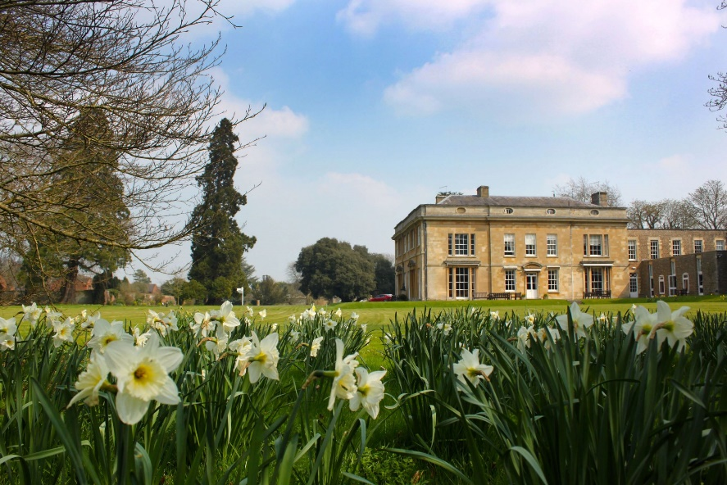

**THE LADY DENMAN RESTAURANT SHORTBREAD**

**ENTRY FORM**

|  |  |  |
| --- | --- | --- |
| **Name** | **………………………………………………** | **.** |
| **WI** | **……………………………………………….** | **.** |
| **Address** | **……………………………………………….** | **.** |
|  | **……………………………………………….** | **.** |
|  | **……………………………………………….** | **.** |
| **Email** | **……………………………………………….** | **.** |
| **Phone** | **……………………………………………….** | **.** |

Please return this form of intention to submit your entry to

WI House NO LATER THAN **Monday, 21st July 2025** with £5 entry fee.

(cheques made payable to NCFWI)



[This Photo](http://ximo.wordpress.com/2009/02/04/la-primera-vegada-despres-de-2-anys) by Unknown Author is licensed under [CC BY-NC](https://creativecommons.org/licenses/by-nc/3.0/)

BACS payments also accepted to

a/c 65202746 sort code 08-92-99

account name Northamptonshire County Fed of WI

This form may be photocopied**.**

The 2025 Pauline Duff Trophy is for

*The (former) Lady Denman Restaurant Shortbread*

* If you ever went to Denman College, you’ll know how delicious the signature shortbread was. Now you can make your own. The recipe is freely available to WI members on My WI.
* You should submit six even circles of shortbread 12 mm / ½ inch thick displayed on a plate.
* The plate must be covered.
* The shortbread must be fresh and not previously frozen and made to the attached recipe only.
* The shortbread will be judged according to WI guidelines.
* The judge’s decision will be final
* Entries must have been made by the person stated on the entry form.
* This form may be photocopied.
* Entry form to be returned to WI House by **Monday, 21st July 2025**
* Entries to be brought to WI House between 10am & 2pm on **Monday, 1st September 2025**
* Judging will take place on **Tuesday, 2nd September 2025**
* Entries will be available for collection between 10am & 2pm on **Wednesday, 3rd September.**
* It will not be possible to display the entries at the AGM in 2025.
* Entry fee £5

RECIPE

Ingredients

6 oz / 170 g plain flour

4 oz / 110 g unsalted butter

2 oz / 60 g caster sugar

Method

1. Cream the butter and sugar together until combined and the butter is soft.
2. Add the flour slowly and combine until the mixture turns into a soft dough.
3. Roll into cling film / shape and then chill in the fridge.
4. Remove from the fridge and gently roll out the dough until it is approximately ½ inch thick. Cut into circles. Place on a baking sheet.
5. Cook at 170oC, 150º fan, gas mark 3 for 12 - 15 minutes or until the biscuits are golden brown and slightly firm to the touch.
6. Sprinkle liberally with caster sugar and leave to cool.

**Scoring**

Points will be awarded for:

* External appearance 4 points maximum
* Internal condition 4 points maximum
* Flavour / Aroma 12 points maximum

The judge’s decision will be final