Presidents and Secretaries Meeting at Alma House

On Tuesday 25th March 2025 from 6.30 pm to 9.00 pm.

This meeting is free to members.

Tea and coffee will be served

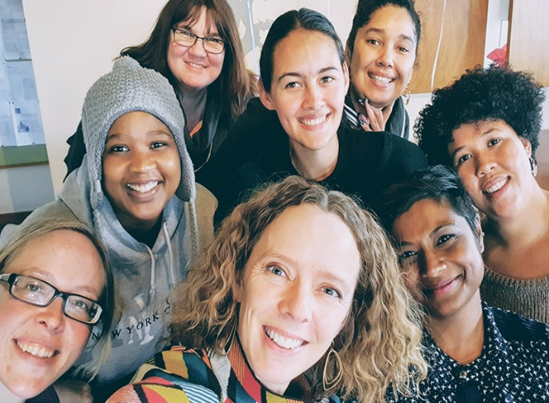

[This Photo](https://www.news.uct.ac.za/article/-2020-09-21-transformation) by Unknown Author is licensed under [CC BY-ND](https://creativecommons.org/licenses/by-nd/3.0/)

***Booking Start Date: 3rd February 2025 – Closing Date:21st March 2025***

**Confirmation will be issued after the closing date**

If the closing date has passed, please contact the Office for availability – 01765 606339

From: WI

|  |  |
| --- | --- |
| **Name and telephone number of member attending** | **Email Address .** |
|  |  |
|  |  |
|  |  |
|  |  |
|  |  |
|  |  |

**Payment Options**

**CHEQUE** payable for the full **AMOUNT** to NYWFWI and send to North Yorkshire West Federation of WIs, Alma House, Low St Agnesgate, Ripon, HG4 1NG. Please list the event on the reverse of the cheque.

**ONLINE-BACS** **Acc Name:** NYW Fed of Womens Institute No 1 A/C Charity No 1204475 **Sort code:** 05-07-17 **Account Number** 35739439 with Reference Name/WI and sending a confirmatory email with completed form to [NYWFWI24@gmail.com](mailto:NYWFWI24@gmail.com). Please quote code **25M01Pres.**

|  |  |  |
| --- | --- | --- |
| Contact Name: Email: | | |
| Telephone Signed | | |
| **BOOKINGS are non-refundable.** | If the event is Cancelled cheques will be destroyed - please tick if you require your cheque returned. |  |

Confirmation will be emailed out to the contact’s name. Please note photographs taken at the event may be used on social media.

**DISCLAIMER**: Participants take part in **ALL** Federation events and activities at their own risk.