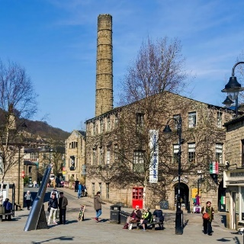
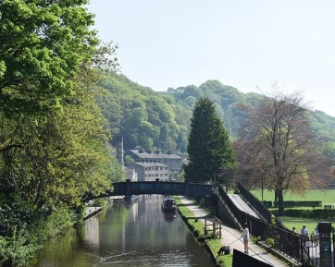
Channel your inner Amazonian EXPLORER!
Wednesday May 21st
Coach pickups in several places from Leyburn & Ingleton
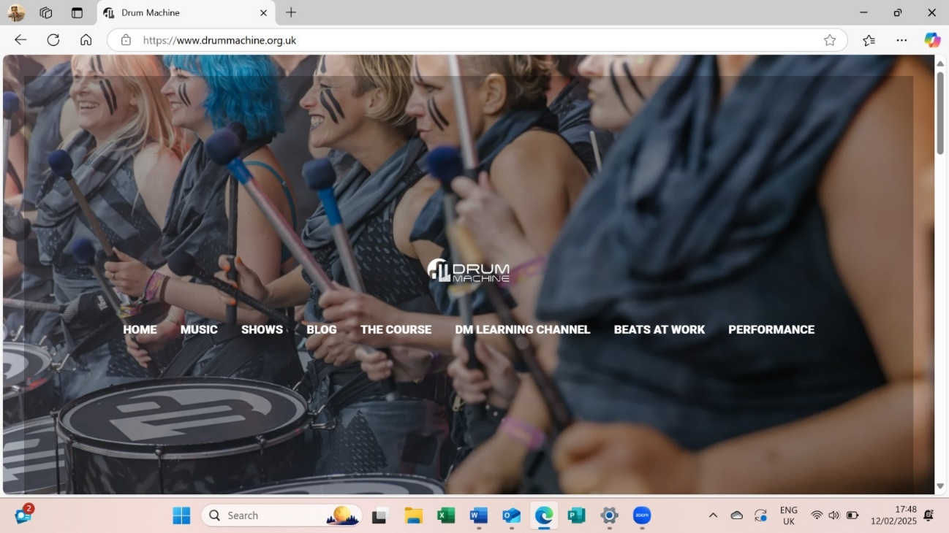
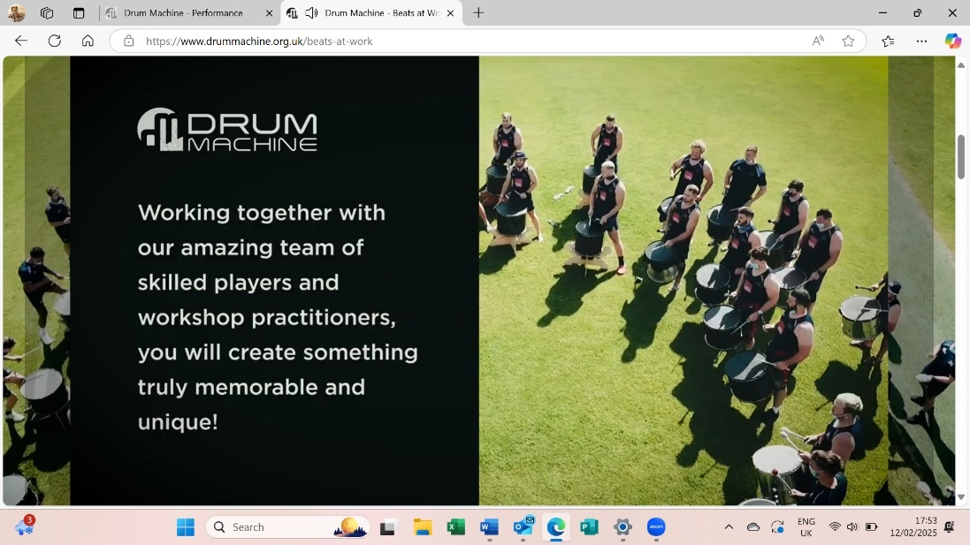
Come to Sowerby Bridge for a funky & uplifting drumming workshop experience with Drum Machine*Then let’s explore Hebden Bridge known for its creative spirit, lots of independent shops, great cafes & local walks.
£35 (for Coach and Drum Workshop)
The Drumming workshop is accessible to ALL as can be seated. Guests welcome £40

Booking start date 1st March. Closing date 14th May.
If the closing date has passed, please contact the office for availability – 01765 606339
****Please turn over page for pick up points and times****

From: WI
Name and telephone number of member attending | Email Address
Payment Options
CHEQUE payable for the full AMOUNT to NYWFWI and send to North Yorkshire West Federation of WIs, Alma House, Low St Agnesgate, Ripon, HG4 1NG. Please list the event on the reverse of the cheque.
ONLINE-BACS Acc Name: NYW Fed of Womens Institute No 1 A/C Charity No 1204475 Sort code: 05-07-17 Account Number 35739439 with Reference Name/WI and sending a confirmatory email with completed form to NYWFWI24@gmail.com. Please quote code 25A09DR

Contact Name: Email:
Telephone Signed
BOOKINGS are non-refundable. | If the event is Cancelled cheques will be destroyed - please tick if you require your cheque returned.
Confirmation will be emailed out to the contact’s name. Please note photographs taken at the event may be used on social media.

DISCLAIMER: Participants take part in ALL Federation events and activities at their own risk.

Arrival at Sowerby Bridge at 11 am
Name | Pick up point | Please tick
 | Leyburn Square 7.30 am | Bedale Square 7.55 am | Ripon Coach Park 8.25 am | Ripley Stores 8.50 am | Bibby’s Depot, Ingleton 9.00 am | Settle Whitefriars Car Park 9.15 am | Skipton Bus Station, Stand 8 9.45 am

