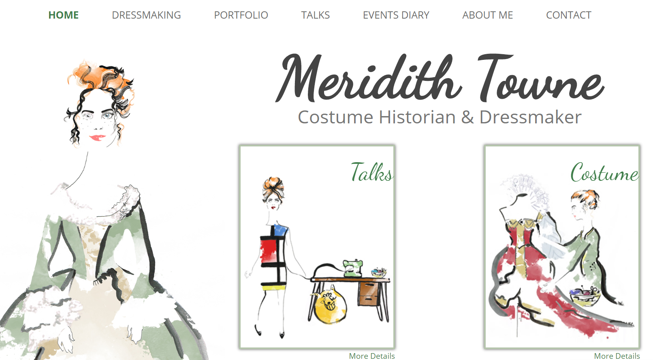

As we Sew The Sixties!

**Rediscover the delights of what was**

**considered shocking fashion in a home**

**dressmaking journey through the**

**decade with Bri-nylon, Crimplene and Simplicity patterns.**

**A whole selection of garments to see from Cindy dolls**

**fashion to beach wear - you will wish you were still sewing in the sixties!**

Friday 2nd May 2025 7pm to 9.30pm

Kettlesing Village Hall, Harrogate, HG3 2LE

£25 For Members £30 for Guests

Includes Cocktail or Mocktail Refreshments

A prize will be awarded to the best Sixties Outfit or accessory worn on the night!

**Booking Starts 17th February & Closes 21st April**

From……………………………………………………………………………………………..WI

|  |  |
| --- | --- |
| **Name/Telephone Number of Member** | **Email Address** |
|  |  |
|  |  |
|  |  |
|  |  |
|  |  |
|  |  |

**Payment Options - CHEQUE** payable for the full **AMOUNT** to NYWFWI and send to North Yorkshire West Federation of WIs, Alma House, Low St Agnesgate, Ripon, HG4 1NG. Please list the event on the reverse of the cheque. **ONLINE-BACS** **Acc Name:** NYW Fed of Womens Institute No 1 A/C Charity No 1204475 **Sort code:** 05-07-17 **Account Number** 35739439 with Reference Name/WI and sending a confirmatory email with completed form to [nywfwi24@gmail.com](mailto:nywfwi24@gmail.com). Please quote code 25A05Fash.

|  |  |  |
| --- | --- | --- |
| Contact Name: Email: | | |
| Telephone Signed | | |
| **BOOKINGS are non-refundable.** | If the event is Cancelled cheques will be destroyed - please tick if you require your cheque returned. |  |

Confirmation will be emailed out to the contact’s name. Please note photographs taken at the event may be used on social media.

**DISCLAIMER**: Participants take part in **ALL** Federation events and activities at their own risk.