DECOUPAGE WORKSHOP

With Sara Baldwin-Cole

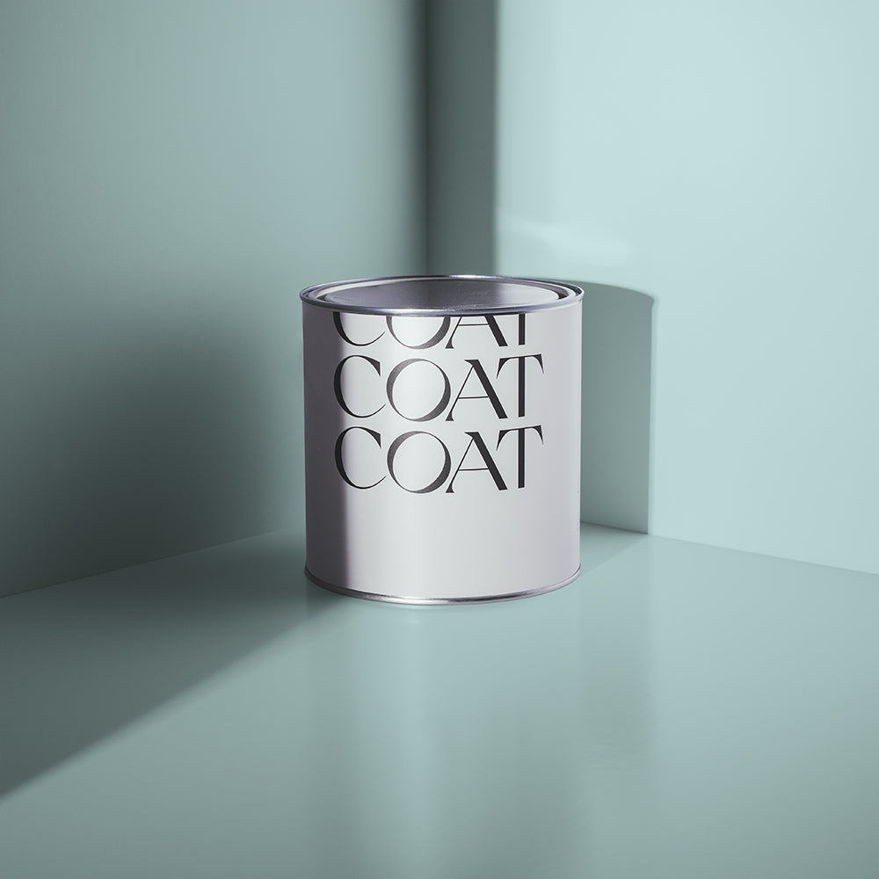Thursday

13th February

10.30 to 3.30pm

Alma House

£25 members

(£30 non-Members)

Materials supplied- just bring your favourite paper scissors.

**Calling all Paper ephemera fans! Come and play snipping and sticking. Several projects : Mache Box & Folder**

**Refreshments on arrival at 10am, Bring a packed lunch.**

**Booking starts 5th December and closes 21st January**

CONFIRMATION will be issued after the closing Date

If the closing date has passed, please contact the office for availability 01765 606339

From:…………………………………………………………………………………………………………………… WI

|  |  |
| --- | --- |
| **Name and telephone number of member attending** | **Email Address .** |
|  |  |
|  |  |
|  |  |
|  |  |
|  |  |
|  |  |

**Payment Options: CHEQUE** payable for the full **AMOUNT** to NYWFWI and send to North Yorkshire West Federation of WIs, Alma House, Low St Agnesgate, Ripon, HG4 1NG. Please list the event on the reverse of the cheque. **ONLINE-BACS** **Acc Name:** NYW Fed of Womens Institute No 1 A/C Charity No 1204475 **Sort code:** 05-07-17 **Account Number** 35739439 with Reference Name/WI and sending a confirmatory email with completed form to [NYWFWI24@gmail.com](mailto:NYWFWI24@gmail.com). Please quote code 25A01Decou.

|  |  |  |
| --- | --- | --- |
| Contact Name: Email: | | |
| Telephone Signed | | |
| **BOOKINGS are non-refundable.** | If the event is Cancelled cheques will be destroyed - please tick if you require your cheque returned. |  |

Confirmation will be emailed out to the contact’s name. Please note photographs taken at the event may be used on social media.

**DISCLAIMER**: Participants take part in **ALL** Federation events and activities at their own risk.