NORTHAMPTONSHIRE COUNTY FEDERATION OF WIs

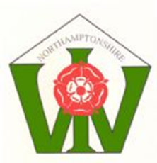

CHALLENGE TROPHY 2025

COMPETITION SCHEDULE

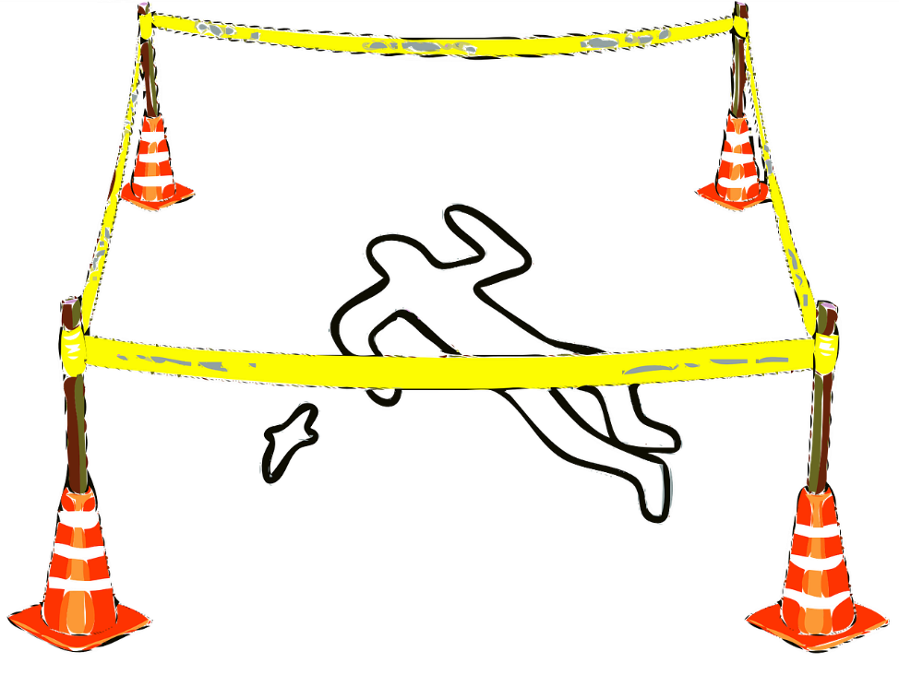

NORTHAMPTONSHIRE COUNTY FEDERATION OF WIs

2025 CHALLENGE TROPHY ENTRY FORM

WI Name ………………………………………………………………

Directors Name ………………………………………………………

Email address ………………………………………………………….

Telephone number …………………………………………………….

Names of all those involved……………………………………………

…………………………………………………………………………….

…………………………………………………………………………….

…………………………………………………………………………….

**Please return this form of intention to submit your entry to**

**WI House, 71 Park View, Moulton, NN3 7UZ**

**NO LATER THAN 28 April 2025**

**Entry Fee of £15.00 must accompany the entry form.**

Cheques to be payable to NCFWI.

BACS payments also accepted a/c 65202746 sort code 08-92-99

account name Northamptonshire County Fed of WI

CHALLENGE TROPHY 2025

We are asking WIs to produce a murder mystery script for radio.

This competition is designed so that members can really showcase their imaginative talents in writing dialogue and generating atmosphere.

Please let your imaginations run riot – the script can be WI or non-WI related; the choice is yours.

A minimum of 3 members from the same WI must be involved in writing and performing; no non-members permitted.

Up to 4 characters + 1 sound effect operator allowed.

The script should be presented in a radio script format and reflect the key elements of a murder mystery.

Appropriate and imaginative sound effects should be used to scene set and enhance action, and these listed in the script.

Maximum total length of 15 minutes for reading and sound Effects.

* Entries must be received at WI House by 31st July 2025. Please arrange a date with WI House prior to bringing entries in.
* Initial judging will be done by script only. Shortlisted entries will have the opportunity to perform their entry live before the final winner is decided (three weeks after script judging date)
* Final judging will be supported by an independent judge.
* Winner will be announced at the 2025 NCFWI AGM.