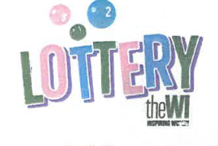
What we’ll cover today:
- How the Lottery works for supporters
- Lottery website
- Prizes
- How it works for good causes
- Your commitment
19TH November 2024
2.00 pm to 4.00 pm and 7.00 pm to 9.00 pm
this will be a hybrid meeting
At Alma House/Zoom
There is no charge for this meeting – funding from the wi training budget

WORKSHOP FOR NATIONAL WI LOTTERY

Booking Start Date: 1st October – Closing Date: 1st November
Confirmation will be issued on 5th November
If the closing date has passed, please contact the Office for availability – 01765 606339

From: WI
If you are attending on Zoom here is the link, which will be repeated with your confirmation.
https://us02web.zoom.us/j/84797134195?pwd=m0JtAhMTvY4VLGQrLW30Obthbgi8TI.1
Name and telephone number of member attending | Email Address | Time – 2-4pm or 7-9pm – please indicate below | In person  Please tick | On Zoom  Please tick

Contact Name: Email:
Telephone Signed
Confirmation will be emailed out to the contact’s name. Please note photographs taken at the event may be used on social media.

DISCLAIMER: Participants take part in ALL Federation events and activities at their own risk.

