Practical Food Safety for WI Members
Incorporating Level 2 Food Safety

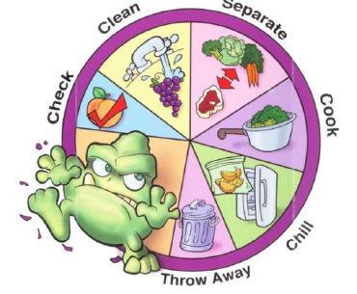
At Alma House
On Wednesday 21st May
10.00 am for 10.30 am start
Approximately 2.30 pm – 3.00pm finish
Run by Anne Hepple-Wilson,
Teacher of Food Technology and Catering
Please bring your own lunch. Attendees will need a lap top or tablet to access the internet.
Cost £10.50 to be paid to NYWFWI.
Individuals will need to register and pay £10.50 + VAT for the online Food Safety Exam on the day.
Participants will complete the certificate online, valid for 3 years.

This is an important qualification when providing catering for Community Lunches, fund raising, cake stalls, visiting coach parties etc.
At least one person must hold this certificate to comply with the law.
Please note, here is limited parking at Alma House

Booking Start Date: 1st March – Closing Date: 9th May
Confirmation will be issued after the closing date
If the closing date has passed, please contact the Office for availability – 01765 606336. Please act quickly to avoid disappointment

From: WI
Name and telephone number of member attending | Email Address .
Payment Options
CHEQUE payable for the full AMOUNT to NYWFWI and send to North Yorkshire West Federation of WIs, Alma House, Low St Agnesgate, Ripon, HG4 1NG. Please list the event on the reverse of the cheque.
ONLINE-BACS Acc Name: NYW Fed of Womens Institute No 1 A/C Charity No 1204475 Sort code: 05-07-17 Account Number 35739439 with Reference Name/WI and sending a confirmatory email with completed form to NYWFWI24@gmail.com. Please quote code 25F03Food

Contact Name: Email:
Telephone Signed
BOOKINGS are non-refundable. | If the event is Cancelled cheques will be destroyed - please tick if you require your cheque returned.
Confirmation will be emailed out to the contact’s name. Please note photographs taken at the event may be used on social media.

DISCLAIMER: Participants take part in ALL Federation events and activities at their own risk.

