Rag rug workshop at alma house
With Mary Cooper

Cost £35 to include all materials
On Tuesday 8th April from 10.00 am to 3.00 pm

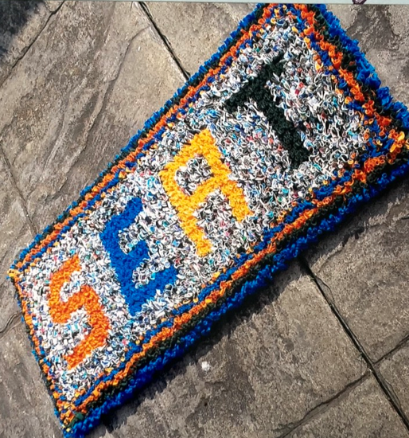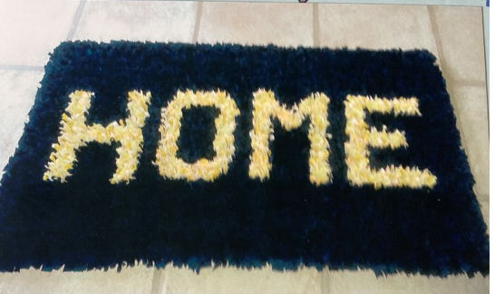
Only 8 places available
Please bring a packed lunch

You will be supplied with all materials to make a door mat. All you need to provide is a pair of sharp scissors

Booking start date 1st January. Closing date 21st March 2025. Confirmation will be issued after the closing date
If the closing date has passed, please contact the office for availability 01765 606339

From:…………………………………………………………………………………………………………………… WI
Name and telephone number of member attending | Email Address .
Payment Options: CHEQUE payable for the full AMOUNT to NYWFWI and send to North Yorkshire West Federation of WIs, Alma House, Low St Agnesgate, Ripon, HG4 1NG. Please list the event on the reverse of the cheque. ONLINE-BACS Acc Name: NYW Fed of Womens Institute No 1 A/C Charity No 1204475 Sort code: 05-07-17 Account Number 35739439 with Reference Name/WI and sending a confirmatory email with completed form to NYWFWI24@gmail.com. Please quote code 25A04Rag.
Contact Name: Email:
Telephone Signed
BOOKINGS are non-refundable. | If the event is Cancelled cheques will be destroyed - please tick if you require your cheque returned.
Confirmation will be emailed out to the contact’s name. Please note photographs taken at the event may be used on social media.

DISCLAIMER: Participants take part in ALL Federation events and activities at their own risk.

