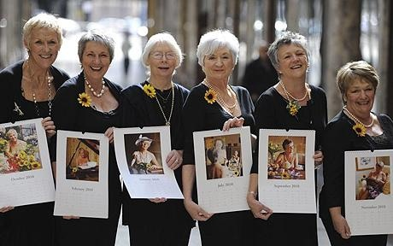It’s **25 Years** since

The Calendar Girls

did their famous calendar

(and really put the WI and The Dales on the map! )

**JOIN US on WEDNESDAY 26th March 2025**

**For a Walk, Talk & Lunch**

**10am to 4pm £30 per person**

**Arthur Anderton Memorial Institute,**

**Lauradale Lane, Linton, Skipton BD23 5HQ**

**A gentle 4-mile beautiful Circular Walk from Linton,*a Soup and Sweet Lunch**

**& a talk by Angela, Trish and a few more of THE Calendar girls!!**

Meet at 10am for coffee, Walk from 10.30am. Lunch 1.00pm followed by the talk.

(* For just the talk and lunch please arrive for 1pm - Ticket Cost is the same)

**A donation to Blood Cancer UK will be made by NYWFWI.**

**BOOK PROMPTLY! Bookings open 2nd January and close 5th March**

Confirmation will be issued after the Closing Date

If the closing Date has passed please contact the Office for availability – 01765 606339

From……………………………………………………………………………………………………………………………………….WI

|  |  |  |  |
| --- | --- | --- | --- |
| Name and telephone No. of member attending | Email Address | Walk & Lunch | lunch only |
|  |  |  |  |
|  |  |  |  |
|  |  |  |  |
|  |  |  |  |
|  |  |  |  |
|  |  |  |  |

**Payment Options: CHEQUE** payable for the full **AMOUNT** to NYWFWI and send to North Yorkshire West Federation of WIs, Alma House, Low St Agnesgate, Ripon, HG4 1NG. Please list the event on the reverse of the cheque. **ONLINE-BACS** **Acc Name:** NYW Fed of Womens Institute No 1 A/C Charity No 1204475 **Sort code:** 05-07-17 **Account Number** 35739439 with Reference Name/WI and sending a confirmatory email with completed form to [NYWFWI24@gmail.com](mailto:NYWFWI24@gmail.com). Please quote code ???????

|  |  |  |
| --- | --- | --- |
| Contact Name: Email: | | |
| Telephone Signed | | |
| **BOOKINGS are non-refundable.** | If the event is Cancelled cheques will be destroyed - please tick if you require your cheque returned. |  |

Confirmation will be emailed out to the contact’s name. Please note photographs taken at the event may be used on social media.

**DISCLAIMER**: Participants take part in **ALL** Federation events and activities at their own risk.