APPLIQUE WORKSHOP WITH ANNE STARKEY AT ALMA HOUSE HG4 1NG

ON TUESDAY 11TH MARCH 2025

10 AM FOR COFFEE, 10.30 AM TO 3.30 PM

COST £25 FOR MEMBERS, £30 FOR NON-MEMBERS

**This workshop is suitable for complete beginners. You may choose between snowdrops or wildflowers. All work will be appliqued by hand, so no sewing machines are required.**

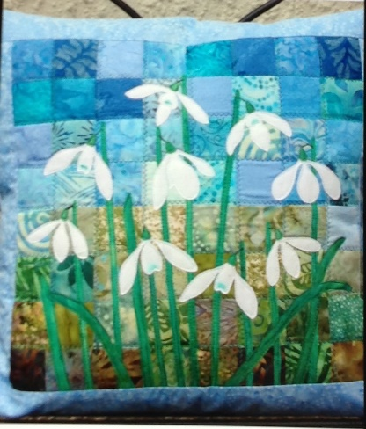

**Please bring a packed lunch. There is limited parking at Alma House**

Booking start date 1st January. Closing date 21st February 2025. Confirmation will be issued after the closing date

If the closing date has passed, please contact the office for availability 01765 606339

From:…………………………………………………………………………………………………………………… WI

|  |  |
| --- | --- |
| **Name and telephone number of member attending** | **Email Address .** |
|  |  |
|  |  |
|  |  |
|  |  |
|  |  |
|  |  |

**Payment Options: CHEQUE** payable for the full **AMOUNT** to NYWFWI and send to North Yorkshire West Federation of WIs, Alma House, Low St Agnesgate, Ripon, HG4 1NG. Please list the event on the reverse of the cheque. **ONLINE-BACS** **Acc Name:** NYW Fed of Womens Institute No 1 A/C Charity No 1204475 **Sort code:** 05-07-17 **Account Number** 35739439 with Reference Name/WI and sending a confirmatory email with completed form to [NYWFWI24@gmail.com](mailto:NYWFWI24@gmail.com). Please quote code 25A03Patch.

|  |  |  |
| --- | --- | --- |
| Contact Name: Email: | | |
| Telephone Signed | | |
| **BOOKINGS are non-refundable.** | If the event is Cancelled cheques will be destroyed - please tick if you require your cheque returned. |  |

Confirmation will be emailed out to the contact’s name. Please note photographs taken at the event may be used on social media.

**DISCLAIMER**: Participants take part in **ALL** Federation events and activities at their own risk.

**PLEASE SEE REVERSE OF FORM FOR MATERIALS REQUIRED**

**Requirements**

**Snowdrop panel**

Piece of fabric for sky 10in x 16in

Piece of fabric for ground 8in x 16in

Fat quarter (18in x 18in approx.) green fabric for stems and leaves Fat quarter (18in x 18in approx.) white fabric for flowers Green and white threads for appliqué

**Wildflowers panel**

White or cream fabric for background 17in square Fat quarter (18in x 18in approx.) green fabric for stems and leaves Flower appliqué - ideal way to use your fabric scraps. In total will need scraps totaling a fat quarter. I will also bring mine.

Green sewing thread and a sewing thread that matches your background.

**In general**

Basic sewing kit i.e. Needles, pins, scissors etc.

Notepad and pen

Pencil for marking design on background fabric

Anne Starkey