***visit to littlethorpe manor gardens hg4 3LG***

***On Thursday 19th June 2025***

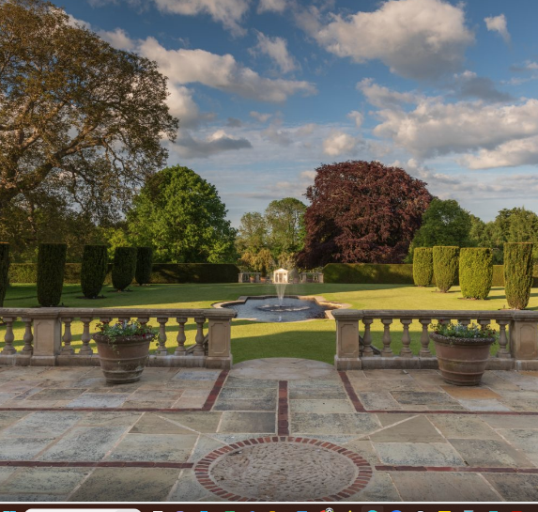

***10.00 am for coffee, tour starts at 10.30 am with Eddie Harland, Head Gardener***

***Cost £17 including refreshments***

***Priority will be given to those members who are on the waiting list from the last trip to the venue.***

**Please let us know of any dietary requirements**

**There is limited parking at the site – please car share if you can**

***Booking Start Date: 1st March – Closing Date: 6th June***

**Confirmation will be issued by email after the closing date.**

If the closing date has passed, please contact the Office for availability – 01765 606339

From: WI

|  |  |  |
| --- | --- | --- |
| **Name and telephone number of member attending** | **Email Address** | **Dietary Requirements** |
|  |  |  |
|  |  |  |
|  |  |  |
|  |  |  |
|  |  |  |

**Payment Options**

**CHEQUE** payable for the full **AMOUNT** to NYWFWI and send to North Yorkshire West Federation of WIs, Alma House, Low St Agnesgate, Ripon, HG4 1NG. Please list the event on the reverse of the cheque.

**ONLINE-BACS** **Acc Name:** NYW Fed of Womens Institute No 1 A/C Charity No 1204475 **Sort code:** 05-07-17 **Account Number** 35739439 with Reference Name/WI and sending a confirmatory email with completed form to [NYWFWI24@gmail.com](mailto:NYWFWI24@gmail.com)**. Please quote code**: **25A06LM**

|  |  |  |
| --- | --- | --- |
| Contact Name: Email: | | |
| Telephone Signed | | |
| **BOOKINGS are non-refundable.** | If the event is Cancelled cheques will be destroyed - please tick if you require your cheque returned. |  |

Confirmation will be emailed out to the contact’s name. Please note photographs taken at the event may be used on social media.

**DISCLAIMER**: Participants take part in **ALL** Federation events and activities at their own risk.